**1. Add 2 Nodes to Jenkins Master**

1. **Open Jenkins Dashboard**:
   * Open your Jenkins instance in a web browser (e.g., http://your-jenkins-url).
2. **Manage Jenkins**:
   * Click on "Manage Jenkins" from the sidebar on the left.
3. **Manage Nodes and Clouds**:
   * Click on "Manage Nodes and Clouds" under the System Configuration section.
4. **Create New Node**:
   * Click on "New Node" (usually located on the left-hand side of the Manage Nodes page).
   * Enter a name for the node (e.g., Node1, Node2).
   * Select "Permanent Agent" and click "OK".
5. **Configure Node**:
   * **Description**: Optionally provide a description for the node.
   * **Remote Root Directory**: Set the path where Jenkins will store files on the node (e.g., /home/jenkins).
   * **Labels**: Add labels to identify the node (e.g., linux, build).
   * **Usage**: Specify how the node should be used (e.g., "Use this node as much as possible").
   * **Launch Method**: Select how Jenkins should connect to this node (e.g., "Launch agents via SSH").
     + **Host**: Enter the IP address or hostname of the node.
     + **Credentials**: Add SSH credentials for the node.
     + **Remote FS Root**: Enter the root directory for Jenkins on the node.
     + **Host Key Verification Strategy**: Configure host key verification if needed.
6. **Save and Connect Node**:
   * Click "Save" to create the node.
   * Ensure the node is connected and online. The node will appear in the list with a status indicating if it's connected.
7. **Repeat for the Second Node**:
   * Follow the same steps to add the second node with appropriate configurations.

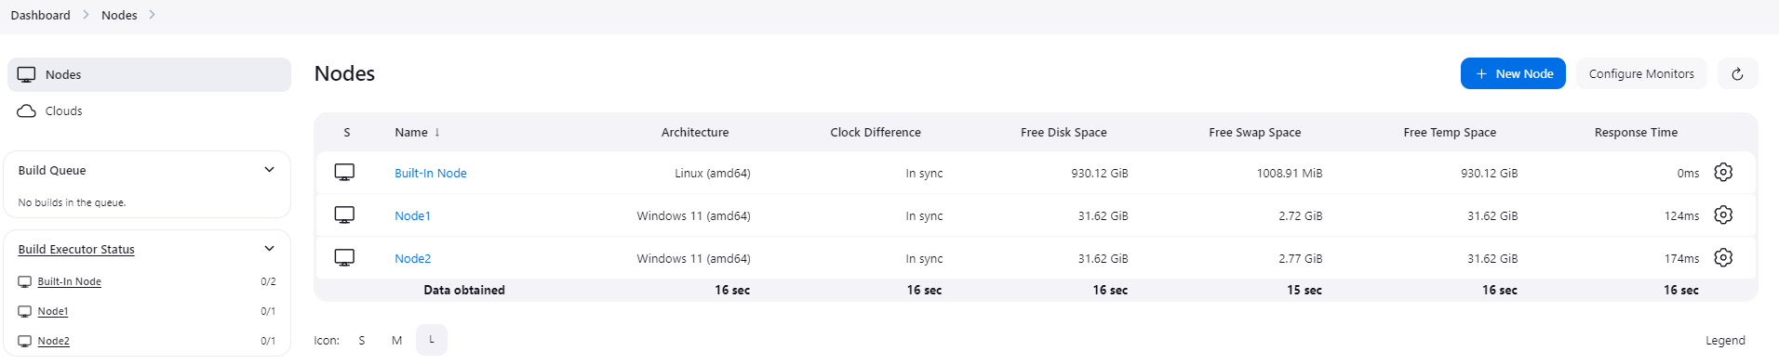

**2. Create Jenkins Jobs**

